Broadway Streetscaping from 16th to 14th
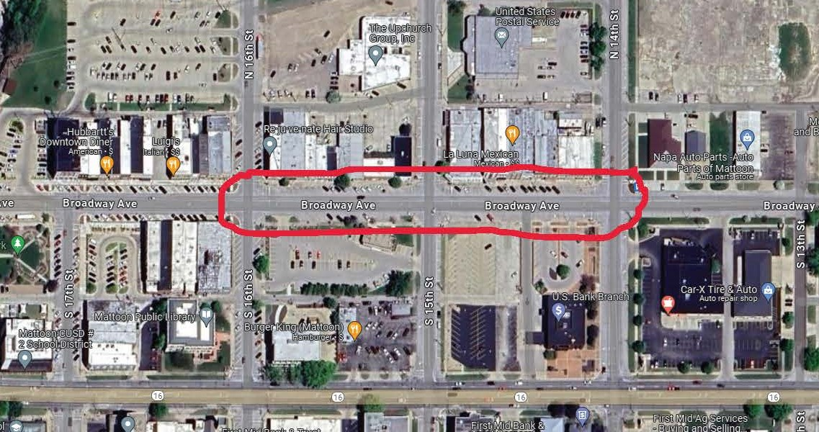

This project is a continuation of the streetscape improvements the City of Mattoon has done from 16th west. This project will continue incorporating the same design and aesthetics that has been used to date.

Work on the project is being done by the same contractor that has done the previous projects, Fuller-Wente, Inc. They plan to begin work on the project starting Monday, March 25, 2024. On Sunday they will set up traffic control and begin blocking off parking along the north side of Broadway between 14th and 16th Streets. On Monday they will start sawing for removals and expect that to take approximately a day and a half, at which point they will then move to the south side. Nothing will be removed at this time. They are currently waiting on the delivery of some materials to replace the water line and services lines along the north side of Broadway. They expect those materials to arrive late next week and will then begin removals and the replacement of the water lines the week of April 1, 2024. Of course, the work is dependent upon weather conditions. Overall, they expect the work to take 2–3 months to complete. Every effort possible will be made to maintain access to your property and businesses throughout the duration of the project.

If you have any questions and concerns with the project, you can contact:
City of Mattoon
David Clark, PE – Public Works Director
208 N. 19th Street
Mattoon, Illinois 61938
clarkd@mattoonillinois.org
(217) 235-5460

Fuller-Wente, Inc. contact information is as follows:
Fuller-Wente, Inc.
Todd Fuller
Fwi67@yahoo.com
(217) 273-5011

